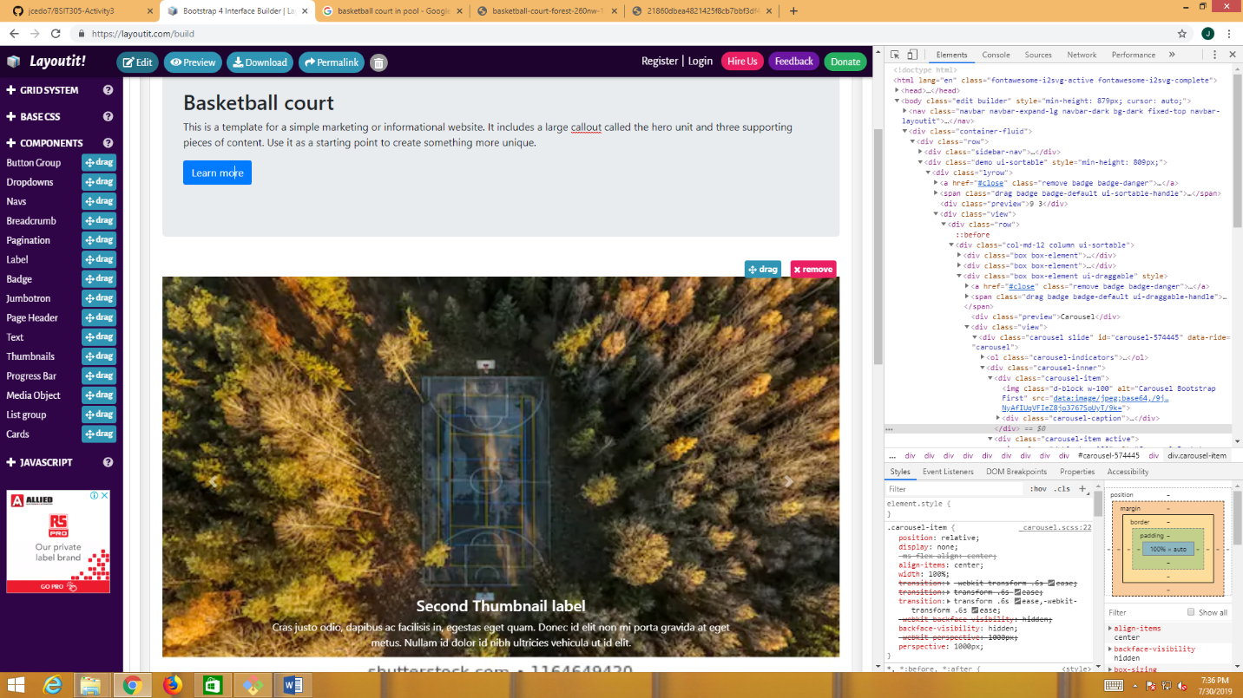

This website is for all basketball player to inspire them that we can play basketball everywhere.